Name: Bilal abid abbasi
Id:45961
Oop lab assignment 02:

Assignment # 2

Object-Oriented Programming (OOP) – LAB

Task 1: Multilevel Inheritance: University Management System
A university wants to develop a simple system to maintain information about individuals working in the institution. The system should be designed using multilevel inheritance to represent different levels of staff information.
First, create a base class Person that stores basic details of a person such as name and age. Next, create a class Employee that inherits from the Person class and includes additional information such as employee ID and department. Finally, create another class Faculty that inherits from the Employee class and stores further details such as subject specialization and number of courses taught.
Your program should demonstrate the concept of multilevel inheritance, where the Faculty class indirectly inherits the properties of the Person class through the Employee class.
Solution:

#include <iostream>
using namespace std;
class Person
{
protected:
string name;
int age;
public:
void getPersonData()
{
cout << "Enter Name: ";
getline(cin, name);

cout << "Enter Age: ";
cin >> age;
cin.ignore();
}

void showPersonData()
{
cout << "Name: " << name << endl;
cout << "Age: " << age << endl;
}
};

class Employee : public Person
{
protected:
int employeeID;
string department;

public:
void getEmployeeData()
{
getPersonData();

cout << "Enter Employee ID: ";
cin >> employeeID;
cin.ignore();

cout << "Enter Department: ";
getline(cin, department);
}

void showEmployeeData()
{
showPersonData();

cout << "Employee ID: " << employeeID << endl;
cout << "Department: " << department << endl;
}
};

// Derived class from Employee
class Faculty : public Employee
{
private:
string specialization;
int coursesTaught;

public:
void getFacultyData()
{
getEmployeeData();

cout << "Enter Subject Specialization: ";
getline(cin, specialization);

cout << "Enter Number of Courses Taught: ";
cin >> coursesTaught;
}

void showFacultyData()
{
cout << "\n--- Faculty Information ---" << endl;

showEmployeeData();

cout << "Specialization: " << specialization << endl;
cout << "Courses Taught: " << coursesTaught << endl;
}
};

int main()
{
Faculty f;

cout << "Enter Faculty Details\n";
cout << "----------------------\n";

f.getFacultyData();

f.showFacultyData();

return 0;
}

Output:

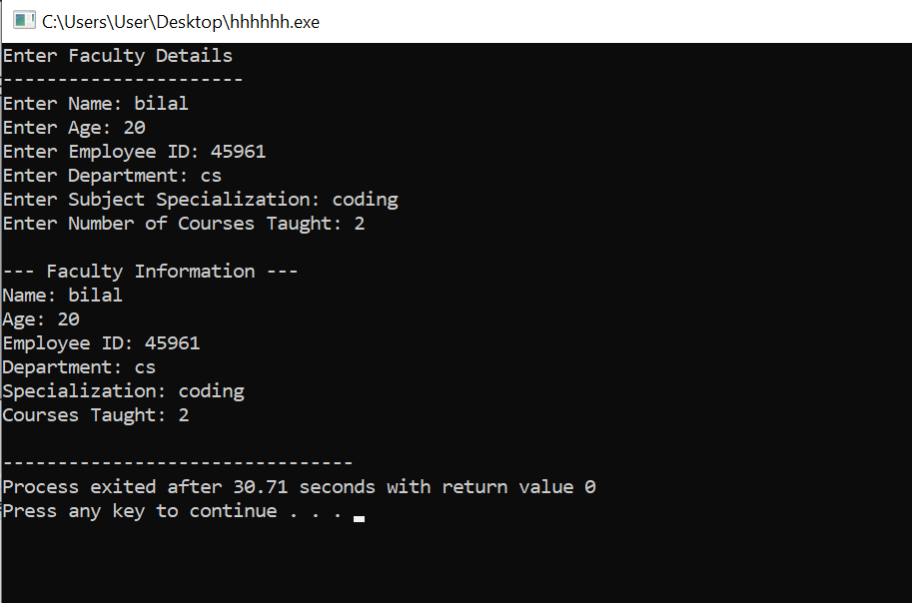

Task 2: Multiple Inheritance: Smart Device System
A technology company is designing a Smart Device that integrates multiple features into a single system. The device should be able to perform different functions such as capturing photos and playing music. To represent this system, you are required to implement multiple inheritance.
First, create a class Camera that includes functionalities related to photography, such as takePhoto() and recordVideo().
Next, create another class MusicPlayer that includes functionalities related to audio playback, such as playMusic() and pauseMusic().
Then create a class SmartPhone that inherits from both Camera and MusicPlayer classes. This class should represent a smartphone that combines the capabilities of both parent classes.
The program should demonstrate how a smartphone can capture photos, record videos, and play music by using methods inherited from both classes.

Requirements:
- Implement appropriate methods in each class to represent their functionalities.
- The SmartPhone class should inherit from both Camera and MusicPlayer classes.
- Create an object of the SmartPhone class and demonstrate how it can access and use the methods of both parent classes.
- Ensure the program clearly demonstrates the concept of multiple inheritance.

Solution:
#include <iostream>
using namespace std;

// First parent class
class Camera
{
public:
void takePhoto()
{
cout << "Photo captured successfully." << endl;
}

void recordVideo()
{
cout << "Video recording started." << endl;
}
};

// Second parent class
class MusicPlayer
{
public:
void playMusic()
{
cout << "Music is playing." << endl;
}

void pauseMusic()
{
cout << "Music paused." << endl;
}
};

// Child class using multiple inheritance
class SmartPhone : public Camera, public MusicPlayer
{
public:
void makeCall()
{
cout << "Calling..." << endl;
}
};

int main()
{
SmartPhone phone;

cout << "SmartPhone Functions\n";
cout << "--------------------" << endl;

phone.takePhoto();
phone.recordVideo();

phone.playMusic();
phone.pauseMusic();

phone.makeCall();

return 0;
}
Output:

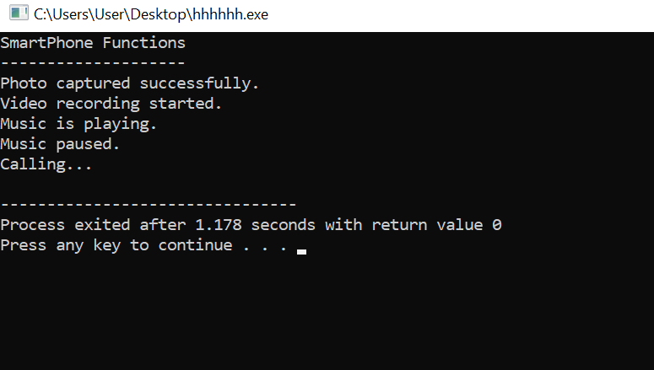

Task 3: Polymorphism: Online Payment System
An online shopping platform allows customers to make payments using different payment methods. The system should be designed in such a way that it can handle various payment types while using a common interface. To achieve this, implement the concept of polymorphism.
First, create a base class Payment that contains a method named processPayment(). This method represents the general process of handling a payment.
Then create the following derived classes:
- CreditCardPayment
- DebitCardPayment
- DigitalWalletPayment
Each derived class should override the processPayment() method and display a message explaining how the payment is processed for that particular payment method.
Your program should demonstrate runtime polymorphism, where the same method name is used but performs different actions depending on the object type.
Requirements:
- Create objects for each payment type.
- Call the processPayment() method using these objects.
- Ensure that each object produces a different output, demonstrating polymorphism.

Solution:
#include <iostream>
using namespace std;

// Base class
class Payment
{
public:
// Virtual function for runtime polymorphism
virtual void processPayment()
{
cout << "Processing payment..." << endl;
}
};

// Derived class 1
class CreditCardPayment : public Payment
{
public:
void processPayment() override
{
cout << "Payment processed using Credit Card." << endl;
}
};

// Derived class 2
class DebitCardPayment : public Payment
{
public:
void processPayment() override
{
cout << "Payment processed using Debit Card." << endl;
}
};

// Derived class 3
class DigitalWalletPayment : public Payment
{
public:
void processPayment() override
{
cout << "Payment processed using Digital Wallet." << endl;
}
};

int main()
{
// Base class pointers
Payment *p1;
Payment *p2;
Payment *p3;

// Objects of derived classes
CreditCardPayment credit;
DebitCardPayment debit;
DigitalWalletPayment wallet;

// Runtime polymorphism
p1 = &credit;
p2 = &debit;
p3 = &wallet;

cout << "Online Payment System\n";
cout << "----------------------" << endl;

p1->processPayment();
p2->processPayment();
p3->processPayment();

return 0;
}
Output:


